Join us on Nov. 18th

for Macy’s exclusive

Trunk Show by

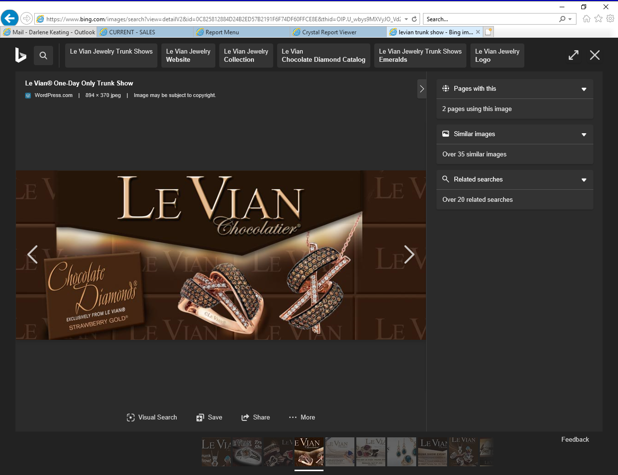

Book an appointment today with

a consultant and receive a

free gift the day of the show.